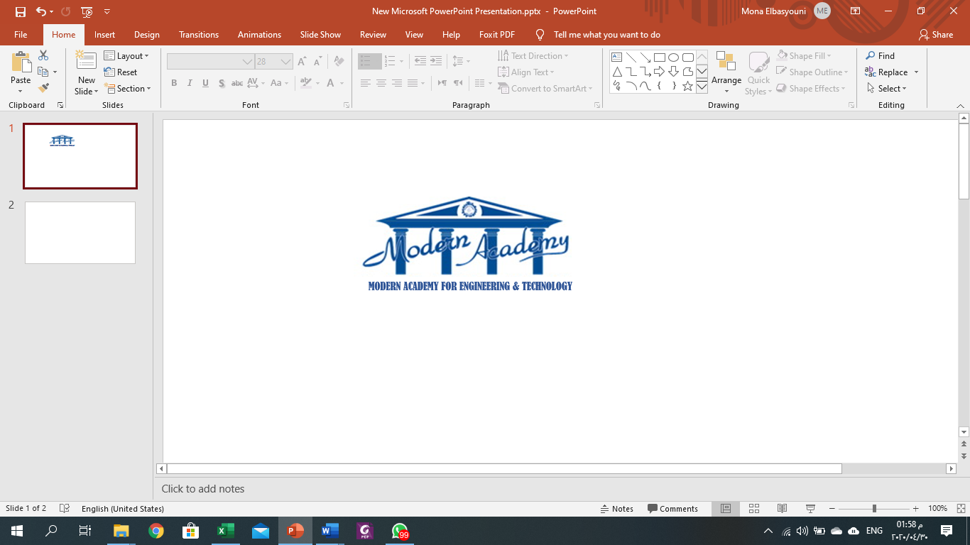
Car Showroom Management System Requirments

team members:
yahya taher
omar mohamed
ramez remon
mohamed adel

Car Showroom Management System

1.Problem definition
Car showrooms and rental businesses traditionally rely on manual or fragmented processes to manage their inventory, customers, and contracts. This leads to inefficiencies such as double-bookings, outdated pricing, poor branch coordination, and a lack of centralized control over operations. There is a clear need for an integrated, web-based system that unifies all these operations under a single platform.

2. Functional Requirements

- User Registration and Login
The system should allow users to create a new account by entering their personal information such as name, email, and password. Users must be able to log in using their registered credentials. The system should also verify user identity and allow secure access to their accounts.

- Car Management
The administrator should have the ability to add new cars to the system by entering details such as car brand, model, manufacturing year, price, and description. The admin should also be able to update or delete car information whenever needed to keep the system data accurate.

- Display Available Cars
The system should provide a page where all available cars in the showroom are displayed. Each car should include detailed information such as model name, brand, price, year of production, and availability status.

- Search and Filter Cars
Users should be able to search for cars using keywords or apply filters such as brand, price range, or model year. This feature helps users quickly find the car that matches their preferences.

- Car Reservation or Booking
Customers should be able to reserve a car through the system. When a user chooses a specific car, the system will allow them to submit a booking request and store the reservation information in the database.

- Customer Inquiry System
The system should allow customers to send questions or inquiries about cars. These inquiries will be stored and accessible to the administrator, who can review and respond to them.

- Car Availability Management
The administrator should be able to update the status of cars in the system. For example, when a car is sold, the admin can mark it as "sold" so that it no longer appears in the available cars list.

- Reports Generation
The system should be able to generate reports that show important information such as the number of available cars, sold cars, and customer reservations. These reports help the showroom management monitor business performance.

3. Non-Functional Requirements

- Performance
The system should operate efficiently and respond quickly to user requests. Pages such as car listings or search results should load within a few seconds to provide a smooth user experience.

- Security
The system must protect user data and ensure secure authentication. Passwords should be encrypted, and the system should prevent unauthorized access to sensitive information.

- Availability
The system should be available to users at all times without major interruptions. Customers should be able to browse cars and make reservations whenever they want.

- Usability
The system interface should be simple, clear, and easy to navigate. Users should be able to understand how to use the system without requiring technical knowledge.

- Scalability
The system should be designed to handle growth in the future. As the number of users, cars, and transactions increases, the system should still perform effectively.

- Reliability
The system should function correctly without frequent errors. It should also protect data from loss and ensure that stored information remains accurate and consistent.

- Maintainability
The system should be designed in a way that allows developers to easily update or improve it in the future without major changes to the structure.

- Compatibility
The system should work correctly on different devices and web browsers, allowing users to access it from desktops, laptops, tablets, or smartphones.

4.SDLC

Phase 1: Planning
Objective: Develop a web-based platform to digitize and centralize all operations of a multi-branch car showroom— replacing manual, error-prone processes with an integrated system.
Feasibility Study:
- Technical: Java Spring Boot + MySQL is a mature, well-supported stack suitable for this scale.
- Operational: Three clearly defined user roles (Customer, Admin) ensure smooth adoption.
- Economic: Open-source tools (Spring Boot, MySQL, Maven) minimize licensing costs.
Project Scope:
- Authentication & role-based access
- Car inventory & pricing management
- Car search & rental contract generation
Stakeholders:
- Showroom owner / Admin
- Customers
- Developers

Phase 2: Requirements Analysis

Phase 3: System Design
Architecture: 3-Tier (Presentation → Business Logic → Data)
[ Frontend: HTML/CSS/JS ]
↓ HTTP REST
[ Backend: Spring Boot (Java) ]
↓ JPA/JDBC
[ Database: MySQL ]
Database Key Tables:
Table | Purpose
accounts | Stores login credentials and roles
customer | Customer personal profiles
employee | Employee records, job, branch, supervisor
car | Car specifications (brand, model, year)
car_color | Available colors per car
car_branch | Inventory count per branch
Car_Price_History | Timestamped price records
Contract | Rental agreements linking customer, car, employee, branch
branch | Physical showroom/rental locations
salary_history | Employee salary changes over time

Phase 4: Implementation
Technology Stack:
Layer | Technology
Backend | Java 17+, Spring Boot
Frontend | HTML5, CSS3, Vanilla JavaScript
Database | MySQL
Build | Maven (mvnw)
Diagrams | Mermaid.js, Draw.io
Module Breakdown:
Authentication Module
- User registration (SSN uniqueness check)
- Login with role detection → redirect to correct dashboard
- Session management
Car Management Module
- CRUD operations on car specs
- Assign cars to branches with quantity
- Price history logging on every price update

Search & Rental Module
- Filter cars by brand, model, color, branch
- Generate contract (validates stock > 0)
- Decrement inventory on booking
- Record payment method

Phase 5: Testing
Testing Levels:
Level | Description | Example
Unit Testing | Test individual methods/functions | Validate SSN uniqueness check
Integration Testing | Test module interactions | Login → Dashboard redirect
System Testing | End-to-end flows | Register → Search → Book car → Contract created
UAT | Real users validate the system | Admin tests onboarding; Customer tests booking
Key Test Scenarios:
- Register with duplicate SSN → expect error message
- Login with wrong password → access denied
- Book a car with stock = 0 → booking blocked
- Update price → old contracts unaffected
- Employee assigned to non-existent branch → validation error
- Search by color + branch → correct filtered results returned

Phase 6: Deployment
Deployment Architecture:
[ User's Browser ]
↓
[ Web Server / localhost ]
↓
[ Spring Boot App (port 8080) ]
↓
[ MySQL Database ]

Phase 7: Maintenance
Known Future Enhancements :
- Connect to a live production database
- Full authentication system hardening
- Performance optimizations for large inventories
- 3D UI effects and modern visual upgrades
- Multi-language support (important for Egyptian/regional market)
- Mobile app version
Ongoing Maintenance Tasks:
- Update car pricing as market changes
- Add new branches and employees as the business scales
- Patch Spring Boot dependencies for security updates

